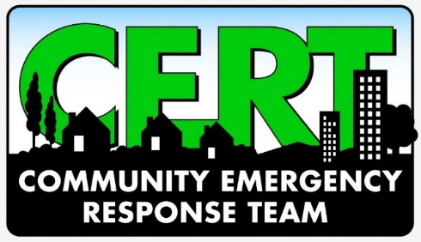

Volunteers Needed for Neighborhood scale exercise!

YOU DO NOT HAVE TO BE A CERT TO TAKE PART IN THIS EXERCISE

We want you! And a few friends and family members….

After an area-wide disaster, as you know, emergency services will likely be overwhelmed.

Join us in an exercise designed to test the feasibility of CERTs reporting to local neighborhood fire stations in the aftermath of an area-wide disaster. In this case, a major earthquake.

We need non-CERT volunteers to play, well, themselves. We need lots of people to simulate area residents after a disaster. Your role would be to drift into the fire station either as a resident who wishes to volunteer to help, or a resident in need of medical attention, in need of other assistance, or simply with questions and nowhere else to go.

Please consider volunteering for this event – and have your friends sign up, too!

EXERCISE
Date: Saturday, March 19, 2016
Time: 9:30 a.m. – 12:00 noon (‘Resident’ volunteers, please arrive by 9:15)
Place: Fire Station 15
80 E 33rd
Eugene, OR

CERT PARTICIPANT MEETING
If you are a CERT and would like to participate, there is a participant meeting that you are strongly urged to attend:

Date: Thursday, March 17, 2016
Time: 6:00 – 8:00 p.m.
Place: Fire/EMS Training Facility
1705 W 2nd
Eugene, OR
ROOMS 1 & 2 (enter from the side doors directly into classroom)

Those of you (and your family/friends) who are not CERTs, and/or are participating as spontaneous volunteers, ‘residents’, or ‘victims’ do not need to attend this meeting – we will meet briefly the day of the exercise.

WHO
CERTs, family, and friends. Any participant under 14 years of age must have parent or guardian with them at all times.

BRING (the day of the exercise)
Your CERT gear, including your vest and city issued identification. If you have misplaced your identification, we can work with that.

WEAR (EVERYONE – CERTS and non-CERTs alike)
Weather and task appropriate clothing. NO open toed shoes

RSVP
Use the link below to sign up for:
Event participation as a CERT
Event participation as a spontaneous volunteer, area ‘resident’, or victim
Participant meeting (active CERTs only)

